

PERSONALIZED MUSIC RECOMMENDATION SYSTEM

Week 6 Status Report

MSDSP 498 - Capstone

Abhigna Mallepally, Anishka Agarwal, Edwin Daniels, Sachin Sharma

February 17, 2025

## Project Status Summary

The team has completed the data enrichment for locale, frontend development, database integration and progressing on backend integration, testing, and optimizing model performance. We will prioritize model enhancements, testing, and cloud deployment this week. Overall, the project progress has been aligned to our plan, however there were a few technical hurdles we had to overcome.

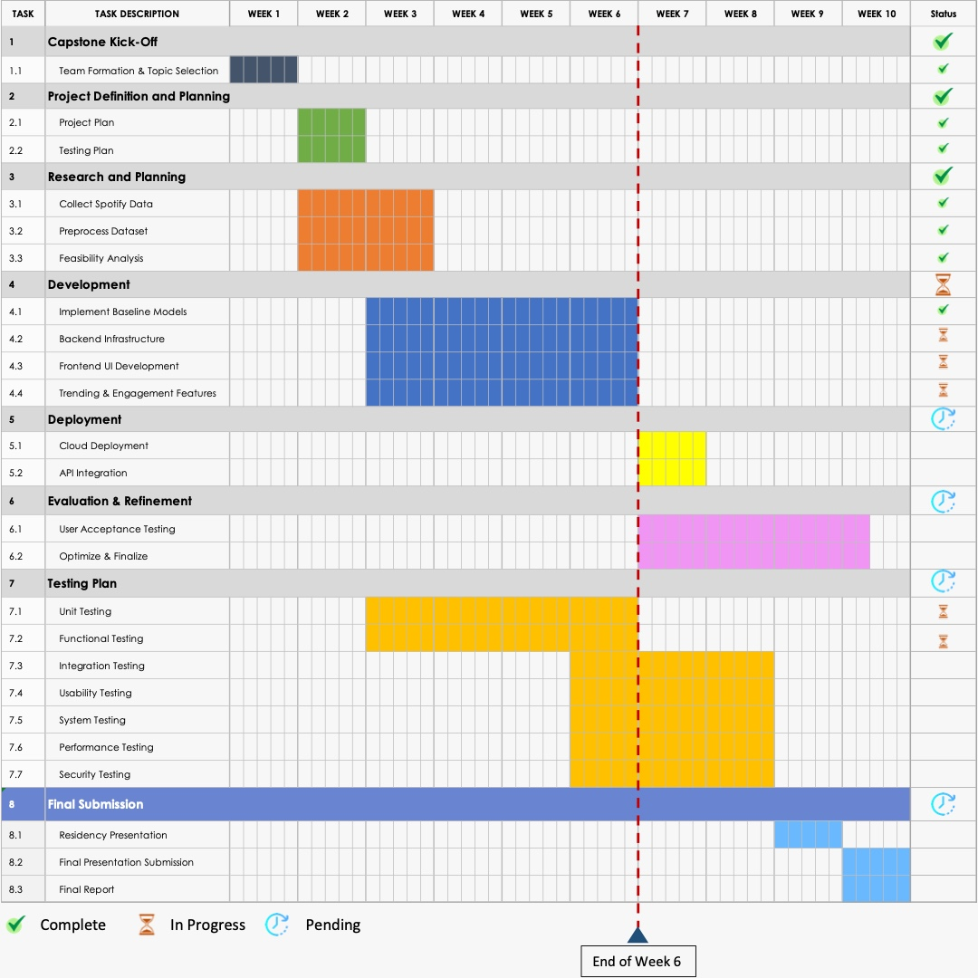

## ****Progress against Plan****

|  |  |  |  |  |
| --- | --- | --- | --- | --- |
| **Phase** | **Planned Tasks** | **Current Status** | **Next Steps** | **Comments** |
| **Data Collection** | Collect users' last 50 songs dataset | ✅ Completed | Train Models. | Successfully gathered user interaction data |
| **Data Preprocessing** | Clean and preprocess 1 million song dataset | ✅ Completed | Add Locale using LLM. | Data ready for enrichment. |
| **Data Enrichment** | Fill missing locale information for songs | ✅ Completed | Review and refine locale data to ensure accuracy | Initial training dataset is completed. |
| **Database Setup** | Create SQL database for user login and preferences | ✅ Completed | Develop functions for CRUD operations | All inputs and app data have been migrated to a database. |
| **Frontend Development** | Build React UI | ✅ Completed | Interact with backend with HTTPS to populate data | Pages have been created for each feature |
| **Backend Development** | Integrate API calls with frontend and database. | 🟡 In Progress | Enhance Chatbot, integrate API calls and optimize model performance. | Initial model training is completed. |
| **Testing** | Continue testing as per the plan | 🟡 In Progress | Start usability, system and performance testing. | Unit and functional testing in progress. |
| **Deployment** | Deploy app to cloud. | 🔴 Not Started | Cloud deployment | Estimated completion in 10 days. |

## ****Risks, Issues & Mitigation Plans****

|  |  |  |  |
| --- | --- | --- | --- |
| **Risk/Issue** | **Impact** | **Mitigation Plan** | **Status** |
| **Slow LLM Processing for Locale Data** | Delays in completing data enrichment | Optimize batch size, explore parallel processing | ✅ Completed |
| **UI Development Complexity** | Potential delays in frontend features | Prioritize core features first | ✅ Completed |
| **Cold-Start Problem for New Users** | Reduced recommendation accuracy for new users | Use genre-based or trending song recommendations | ✅ Completed |
| **Chat Feature - context awareness** | Limited ability to provide better recommendations for users | Use langchain framework to create context aware bot | 🟡 In Progress |
| **Cloud Deployment**  **Delays** | Could affect overall project timeline | Start cloud infrastructure setup in parallel with UI-backend integration | 🔴 Not Started |
| **Testing**  **Delays** | Could impact quality assessment and issue resolution | Testing is performed in parallel to development efforts | 🟡 In Progress |
| **Data Quality** | The locale and genre data quality will impact the quality of recommendations | Leveraging public datasets and lyrics APIs along with improved LLM inference for locale accuracy | ✅ Completed |
| **Database Queries** | Slow application response time | Optimize indexing, caching strategies, and database query execution | 🟡 In Progress |
| **Feedback Implementation** | Delays in adapting user feedback could slow down iteration cycles | Prioritize critical feedback first and phase out minor adjustments over future releases | 🟡 In Progress |

## ****Next Week’s Priorities****

* **Backend Development**

**The backend development phase is approaching completion, with the primary focus now on integrating backend APIs with frontend and database. Seamless data flow and real-time synchronization will be crucial for enhancing user experience and maintaining application stability. Additionally, we will optimize model performance to deliver faster responses, reduce latency, and improve efficiency. A key activity will be enhancing the chatbot functionality by improving response accuracy, refining conversation flow, and incorporating contextual memory to make interactions more engaging, and create a more dynamic and interactive recommendation system tailored to individual user preferences.**

* **Testing**

**With unit and functional testing already in progress, the next step is to verify API endpoints, test database interactions, and validate model outputs to ensure they align with expected behaviors. Usability and system testing will commence to gather insights on user interactions and refine UI/UX for better accessibility and engagement, test end-to-end workflows, ensuring that all components function cohesively across different environments. We will continue performance testing to evaluate system speed, scalability, and responsiveness under various load conditions to determine the application’s capacity to handle peak user activity without degradation in performance.**

* **Deployment**

**A major milestone in the coming week is setting up the cloud environment to host the application. The deployment strategy will include configuring server instances, setting up database hosting, and ensuring secure API communication. CI/CD pipelines will be established to automate testing and deployment, ensuring smooth updates and minimizing downtime. Deployment of both backend and frontend components will be carefully managed to avoid service disruptions. Additionally, security measures will be implemented to protect user data and maintain compliance with best practices.**

* **Further Refinements**

**Before the app deployment, any inconsistencies or incorrect mappings will be corrected to enhance personalization and relevance in music recommendations. Any issues identified during testing will be addressed promptly, including UI/UX improvements, API optimizations, and bug fixes.**